14/02/21

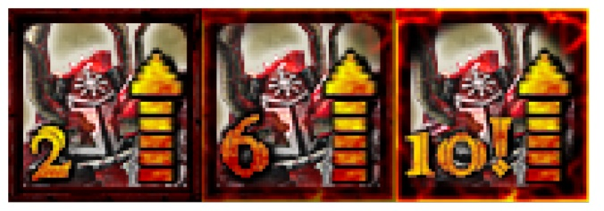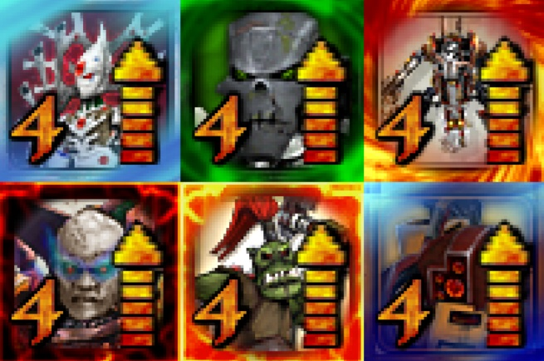Before I started on uni work, did some new icons for a mod I’m (still) working on.

17/02/21

Started working on my programming task and finished my first programming brief. The brief was to make a speedometer to measure the speed in MPH of the object. The task is to make a selection system for an RTS. It’s proving kinda complicated.

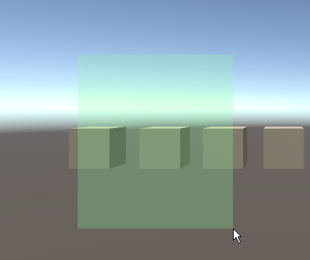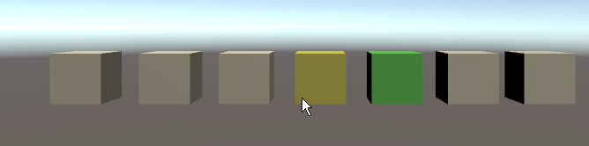

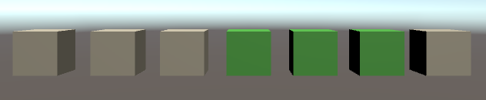

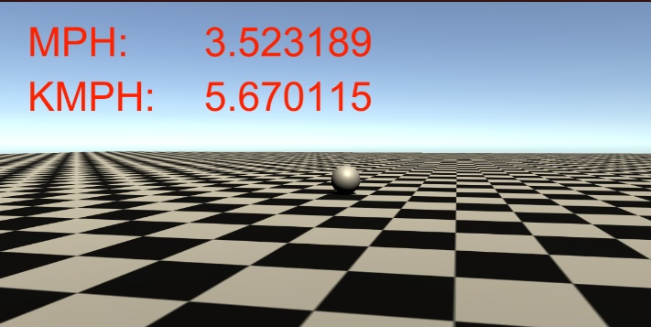

18/02/21

Wrote the first story idea for my organic modelling and sketched the characters, it’s a story about aliens enslaving humans to act as clowns and jesters for them. Yeah. Weird

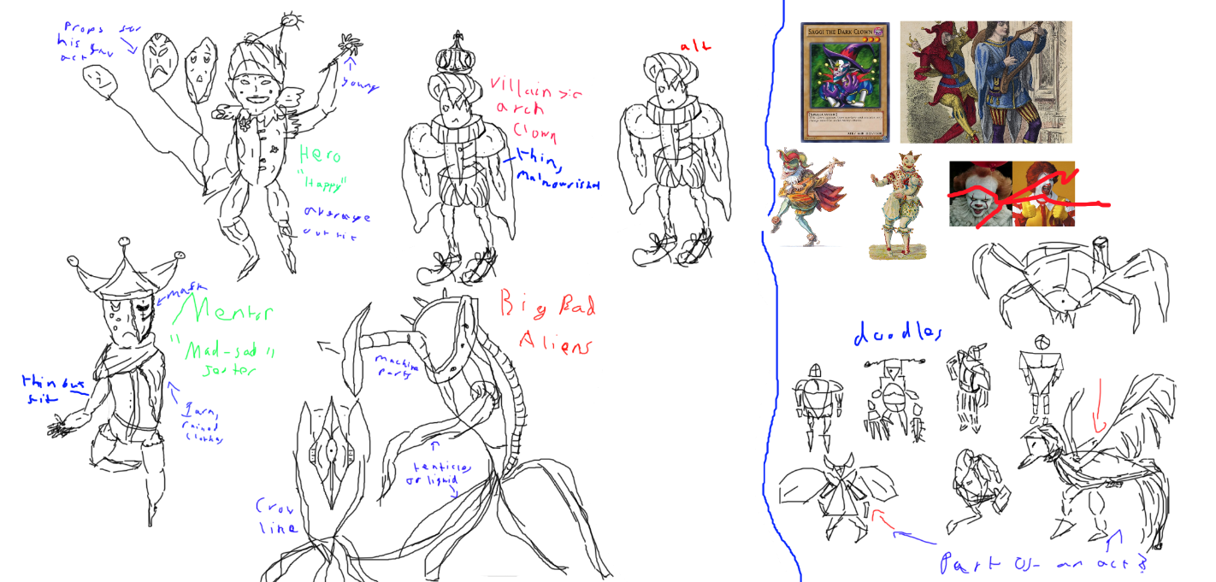

23/02/21

Had some annoying issues with my selection mechanic, it has become very buggy. Now I see my method for selecting is rather bad and confusing. I should not separate code by allowing both individual objects to manage their selection and a master object, as these 2 scripts interfere with each other. For now, I have made it so the individual selection code is paused when clicking and dragging is taking place so there is no interference. Although this code is not ideal, it works, and so I am calling this done.

23/02/21

Started work on my first Specialism brief, a speedometer, and finished it. Made code to make the ball randomly move around, though actually it would have been better to make this effect using player input to move the ball. Calculated the velocity by taking the movement in every direction and averaged it. The scale is 1m = 1 unit block, although I made it so this scale can be adjusted.

24/02/21

Started work on my second specialism brief, a currency system. This is alien to me and I totally don’t understand the currency itself. I spent a lot of the time today researching it. In the end I decided to just spend today creating the data sets for all the coins, separating them into 3 arrays of pennies, farthings and shillings.

25/02/21

Started work on my second programming component. I have chosen to make a lifebar, which colour scales from red to green depending on the amount of HP. Started work and have managed to have a simple lifebar with a static colour and size.

26/02/21

Had some problems with my lifebar mechanic, but ultimately completed it. Made it so the lifebar changed colour and scale with interaction to a ui slider. The code is rather simple, and so took very little time to create. Having said this, it is a good component and I already see it will have use in my other projects.



26/02/21

Made a character sketch for my clown character to help me model him for organic modelling.

<https://www.youtube.com/watch?v=V0TGlB2JWY0>

27/02/21

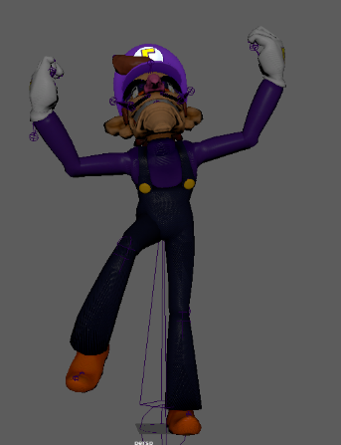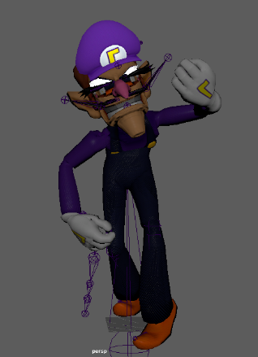Practised with posing characters using an existing professional rig. I did this because I have never worked with rigging or animation before, and I needed to et to know what a good rig looks like and how it works.

04/03/21

Did some non-uni modding work by creating a new map for a game inspired by the C&C Temple Prime map.

<https://www.youtube.com/watch?v=y1idObQh_F4&feature=emb_title>

05/03/21

Started modelling my clown character for organic modelling. It’s an early start but I’m really happy with how it’s coming along!

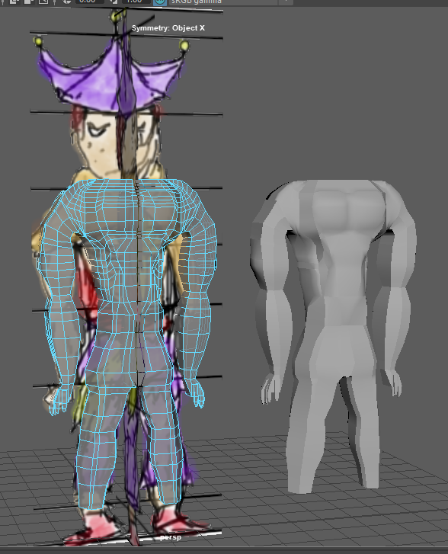

05/03/21

In the specialism call Andy talked about independently driven work and it inspired me to make a unity VFX for the eye of Sauron, I’m not done but here’s the start.

<https://twitter.com/i/status/1367945738806829062>

07/03/21

Finished by graphic for the eye of Sauron, made it animate also to look around, really happy with it!

<https://twitter.com/i/status/1368402181666246660>

16/03/21

Started work on my third programming component. This component creates random loot when objects are destroyed, like an RPG game. I was able to make the looting mechanic today, which activates on destruction of the gameobject. Again the code is rather simple, but will have lots of applications for other projects I will be working on.

Started work on my fourth programming component, a production component. I predict this one will be most challenging out of all the components, although selection was difficult too. I created a custom data type called EBPs (entity blueprints) and SBPs (squad blueprints) to store data for produced units. As well I made a dynamic button system that generates a new button to produce each unit, allowing for multiple units to be available for production. Had some issues using arrays and so transitioned into the more dynamic structure of lists.

17/03/21

Finished off with the production mechanic, although this was more complicated, I was able to make it fast due to a lot of planning I did beforehand. Had some minor issues, but overall, the code works fine now. It is pretty much just code for a specialised queue mechanic and so was somewhat simple to create.



18/03/21

Continued work on my currency brief, today I made some good breakthrough and have the code mostly working in the console and printing the correct coin combinations. This is really satisfying to finally have the code printing a desired output.

Added a UI to the currency brief to make it presentable. This came with a few complications as dynamically inputting money is slightly different to how I originally used the code, although this was fixed. I think this brief is finished now.

19/03/21

Continued work on my 3D modelling and added the character to mixamo to test him out.

Also made my first ever animation in organic modelling class today.

<https://twitter.com/i/status/1372877785497227268>

23/03/21

Did some EXTENSIVE planning for my AGP project. I am going to make an RTS game.

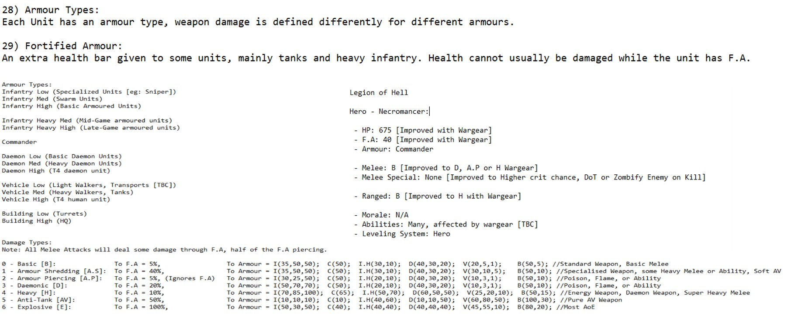Also began adding this as data structures into a unity project to begin working on the project.

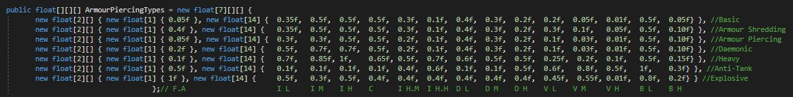

25/03/21

Started work on my game project, I am planning to make a game where you shoot coins to gain score. The four components I am planning to make for it are: 1) Shooting, 2) Object Spawning, 3) Score, 4) Dynamic UI and winstate.

29/03/21

Minor work on my programming game project, made objects spawn under a parent for neatness. As well added some safeguarding code to prevent errors. Finally made some significant change to my code by changing the structure from using the Invoke function to running in the update using timers.



01/04/21

Added my production component into my recreation game project to allow me to create units in the game.

02/04/21

For my programming game, added a reload system for my shooting mechanic so that the score would not instantly reset to 0 on a miss.

04/04/21

Continued work on my currency mechanic, started working on the maths of it but it is so confusing. I made progress but not much to show from it just yet.

05/04/21

Added the selection code to my recreation game project to let me control and move objects, this was kind of difficult to do and the code is buggy, but at least it is somewhat working for now.

06/04/21

Added a damage system to my recreation game project. This uses a complex system of shield and HP, as well it uses armour type and damage types. I’m super excited by how this is coming along.

08/04/21

Took a break from the currency system and started work on my third specialism brief. This was to make an auto scaling text box. Unlike the currency brief, this was rather simple, and I completed it in just today.

09/04/21

Spent a long time on my programming game essentially doing nothing. Had a bug where the score would not update, it turns out the problem was just that the UI object was not big enough to show the text, and to fix I just needed to increase its size… sigh.

11/04/21

Added ranged combat into my recreation game project, this prevents shooting unless the unit is at a certain range.

<https://twitter.com/i/status/1381352364368670729>

12/04/21

For my programming game, made an accuracy recorder and improved the UI to show hits, misses and accuracy. Had some problems with simple math but fixed this.

13/04/21

Learnt today how to use the clothing system in maya to help give my clown character some clothes. This saved me a lot of time instead of straight up modelling all the clothing myself.

14/04/21

Tested out Maya quick rig to rig my character. It looks really good!

https://twitter.com/i/status/1382383216846385154

16/04/21

Revisted my random loot component for programming. Edited some simple things like the loot parent and making the program look nicer by making objects drop in different spots so they didn’t fly off each other.



20/04/21

Finished the code for my programming shooting game, it now works perfectly. It has changed slightly since my original design and now is more of an aim-bot style game, but still it retains the original 4 components.

https://twitter.com/i/status/1384570617580634118

21/04/21

Started work on my final specialism brief, to make an FPS recorder. I made the whole script today, though only have it printing in the console rather than showing it properly to the user. I will come back to edit this later.

26/04/21

Started texturing my clown 3d model. I love how the skin turned out!

27/04/21

Some polish for my programming game, 3D objects for coin and some lighting / colours, as well as a custom cursor.

Finished my final specialism brief by adding a graph graphic to allow my FPS to be seen by the user. I got a lot of help from a youtube video, though in the end I still had to edit their script a lot to support what I needed it to do.

https://twitter.com/i/status/1387063746732957702

28/04/21

Added instructions, lose, and win screen for my programming game. As well, overcame a small problem with restart button not working.

31/04/21

Created some preload settings for my recreation game, importantly added a preview scene that I will be able to present for my game pitch to show some mechanics.

05/05/21

Finished texturing my 3d clown character.

06/05/21

Started animating my organic modelling scene.

<https://twitter.com/i/status/1390405347987312642>

07/05/21

Revisited my currency brief as I realised, I did not fully achieve the brief. It also asks to compare 2 currency combos to determine which has more value. I simply did this by duplicating the existing script to a new object and adding another script that compares their value.